Model Motor Insurance

Murtada Khalafalla

5/8/2020

# Frequency Model

# 1- Poisson Distribution

glm.p <- glm(formula = y1 ~ x1 + x2 + x3 + x4 + x5 + x6 + x7 + x8 + x9 + x10 ,family = poisson(link = log), data = freq_df)

# 1.1- Summary Poassion

##   
## Call:  
## glm(formula = y1 ~ x1 + x2 + x3 + x4 + x5 + x6 + x7 + x8 + x9 +   
## x10, family = poisson(link = log), data = freq_df)  
##   
## Deviance Residuals:   
## Min 1Q Median 3Q Max   
## -1.3526 -0.9745 -0.8522 0.5791 6.0647   
##   
## Coefficients: (2 not defined because of singularities)

|  |  |  |  |  |
| --- | --- | --- | --- | --- |
|  | **Estimate** | **Std. Error** | **z value** | **Pr(>|z|)** |
| (Intercept) | -0.515989 | 0.070010 | -7.370 | 1.70e-13 *** |
| x1Female | 0.079128 | 0.033798 | 2.341 | 0.019223 * |
| x225-30 | -0.152165 | 0.044321 | -3.433 | 0.000596 *** |
| x2>60 | 0.168376 | 0.042699 | 3.943 | 8.04e-05 *** |
| x218-24 | -0.427974 | 0.070642 | -6.058 | 1.38e-09 *** |
| x3Engineer/Programmer | 0.040139 | 0.036927 | 1.087 | 0.277037 |
| x3Medical Profession | -0.168033 | 0.052523 | -3.199 | 0.001378 ** |
| x3Business man/woman | -0.136367 | 0.062573 | -2.179 | 0.029308 * |
| x3Free Lancer | -0.245642 | 0.045742 | -5.370 | 7.87e-08 *** |
| x3Student | 0.045193 | 0.076114 | 0.594 | 0.552682 |
| x3Others | -0.158007 | 0.036473 | -4.332 | 1.48e-05 *** |
| x4Khartoum Bahari | -0.084340 | 0.030429 | -2.772 | 0.005577 ** |
| x4Oumdrman | -0.130716 | 0.029617 | -4.414 | 1.02e-05 *** |
| x56-10 | -0.014461 | 0.035142 | -0.412 | 0.680705 |
| x511-20 | -0.210038*** | 0.039392 | -5.332 | 9.72e-08 |
| x5>20 | 0.020955 | 0.038884 | 0.539 | 0.589942 |
| x6Japan | 0.007278 | 0.111624 | 0.065 | 0.948011 |
| x6Sudan | 0.073378 | 0.062644 | 1.171 | 0.241460 |
| x6Germany | 0.145606 | 0.123501 | 1.179 | 0.238403 |
| x6Czech | 0.243679 | 0.096858 | 2.516 | 0.011875 * |
| x6Others | -0.098652 | 0.141185 | -0.699 | 0.484712 |
| x7Kia | 0.149705 | 0.070113 | 2.135 | 0.032746 * |
| x7Toyota | -0.016494 | 0.137534 | -0.120 | 0.904541 |
| x7Mitsubishi | 0.001595 | 0.167513 | 0.010 | 0.992403 |
| x7Giad | NA | NA | NA | NA |
| x7Mercedes | -0.113537 | 0.168804 | -0.673 | 0.501204 |
| x7Skoda | NA | NA | NA | NA |
| x7Others | -0.098344 | 0.102400 | -0.960 | 0.336860 |
| x8Click | -0.189749 | 0.061569 | -3.082 | 0.002057 ** |
| x8Tucson | 0.334805 | 0.097172 | 3.445 | 0.000570 *** |
| x8Santa Fe | 0.448586 | 0.112911 | 3.973 | 7.10e-05 *** |
| x8Visto | -0.421276 | 0.134668 | -3.128 | 0.001758 ** |
| x8Corolla | 0.083121 | 0.093601 | 0.888 | 0.374521 |
| x8Hilux | 0.404944 | 0.123897 | 3.268 | 0.001082 ** |
| x8Prado /  Land Cruiser | 0.395867 | 0.129387 | 3.060 | 0.002217 ** |
| x8Lancer | -0.092237 | 0.156145 | -0.591 | 0.554713 |
| x8BYD | -0.045376 | 0.113552 | -0.400 | 0.689445 |
| x8Others | -0.102144 | 0.055257 | -1.849 | 0.064525 . |
| x90-5 | 0.040291 | 0.032190 | 1.252 | 0.210695 |
| x911-20 | -0.185251 | 0.033043 | -5.606 | 2.07e-08 *** |
| x9>20 | -0.446654 | 0.088166 | -5.066 | 4.06e-07 *** |
| x10Medium | 0.016908 | 0.054089 | 0.313 | 0.754582 |
| x10Large | -0.464292 | 0.088528 | -5.245 | 1.57e-07 *** |

## ---  
## Signif. codes: 0 '***' 0.001 '**' 0.01 '*' 0.05 '.' 0.1 ' ' 1  
##   
## (Dispersion parameter for poisson family taken to be 1)  
##   
## Null deviance: 16475 on 14684 degrees of freedom  
## Residual deviance: 16043 on 14644 degrees of freedom  
## AIC: 26606  
##   
## Number of Fisher Scoring iterations: 6

# 

# 1.2- ANOVA Poassion

## Analysis of Deviance Table  
##   
## Model: poisson, link: log  
##   
## Response: y1  
##   
## Terms added sequentially (first to last)  
##

|  |  |  |  |  |  |
| --- | --- | --- | --- | --- | --- |
| ## | Df | Deviance | Resid. Df | Resid. Dev | Pr(>Chi) |
| ## NULL |  |  | 14684 | 16475 |  |
| ## x1 | 1 | 7.163 | 14683 | 16468 | 0.0074427 ** |
| ## x2 | 3 | 69.647 | 14680 | 16399 | 5.079e-15 *** |
| ## x3 | 6 | 69.928 | 14674 | 16329 | 4.231e-13 *** |
| ## x4 | 2 | 22.914 | 14672 | 16306 | 1.057e-05 *** |
| ## x5 | 3 | 39.715 | 14669 | 16266 | 1.225e-08 *** |
| ## x6 | 5 | 23.437 | 14664 | 16243 | 0.0002784 *** |
| ## x7 | 5 | 26.158 | 14659 | 16216 | 8.314e-05 *** |
| ## x8 | 10 | 63.984 | 14649 | 16152 | 6.338e-10 *** |
| ## x9 | 3 | 65.949 | 14646 | 16086 | 3.143e-14 *** |
| ## x10 | 2 | 43.922 | 14644 | 16043 | 2.901e-10 *** |

## ---  
## Signif. codes: 0 '***' 0.001 '**' 0.01 '*' 0.05 '.' 0.1 ' ' 1

# 1.3- Ploting Poassion

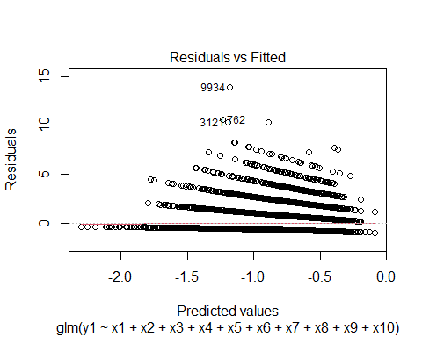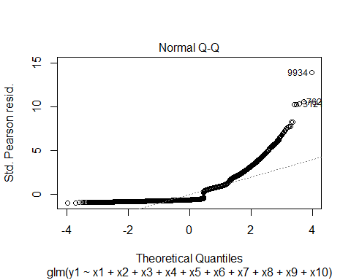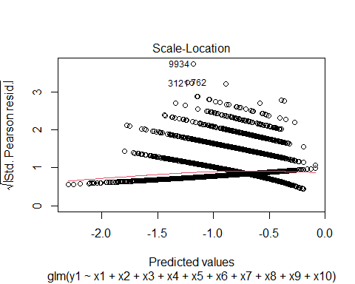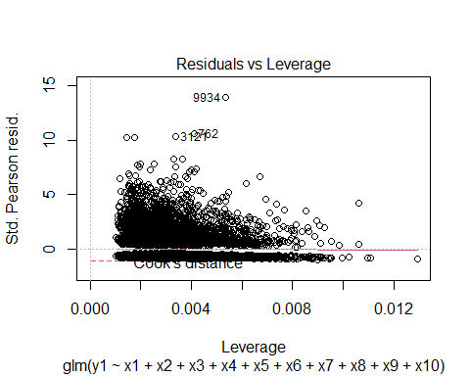

# 2- Negative Binomial Distribution

glm.negb<- glm.nb(formula = y1 ~ x1 + x2 + x3 + x4 + x5+ x6 + x7 + x8 + x9 + x10, link = log, data = freq_df)

# 2.1- Summary Negative Binomail

##   
## Call:  
## glm.nb(formula = y1 ~ x1 + x2 + x3 + x4 + x5 + x6 + x7 + x8 +   
## x9 + x10, data = freq_df, link = log, init.theta = 1.53361257)  
##   
## Deviance Residuals:   
## Min 1Q Median 3Q Max   
## -1.1993 -0.9097 -0.8072 0.4824 4.5503   
##   
## Coefficients: (2 not defined because of singularities)

|  |  |  |  |  |
| --- | --- | --- | --- | --- |
| **##** | **Estimate** | **Std. Error** | **z value** | **Pr(>|z|)** |
| (Intercept) | -0.511780 | 0.080360 | -6.369 | 1.91e-10 *** |
| x1Female | 0.081246 | 0.038886 | 2.089 | 0.036678 * |
| x225-30 | -0.149850 | 0.050159 | -2.987 | 0.002813 ** |
| x2>60 | 0.170552 | 0.049532 | 3.443 | 0.000575 *** |
| x218-24 | -0.421429 | 0.078343 | -5.379 | 7.48e-08 *** |
| x3Engineer/Programmer | 0.037975 | 0.042686 | 0.890 | 0.373666 |
| x3Medical Profession | -0.168768 | 0.059685 | -2.828 | 0.004689 ** |
| x3Business man/woman | -0.136835 | 0.071396 | -1.917 | 0.055295 . |
| x3Free Lancer | -0.247897 | 0.051306 | -4.832 | 1.35e-06 *** |
| x3Student | 0.029611 | 0.086061 | 0.344 | 0.730795 |
| x3Others | -0.158145 | 0.041544 | -3.807 | 0.000141 *** |
| x4Khartoum Bahari | -0.085030 | 0.034833 | -2.441 | 0.014644 * |
| x4Oumdrman | -0.131025 | 0.033777 | -3.879 | 0.000105 *** |
| x56-10 | -0.014819 | 0.040281 | -0.368 | 0.712959 |
| x511-20 | -0.213158 | 0.044682 | -4.771 | 1.84e-06 *** |
| x5>20 | 0.018202 | 0.044733 | 0.407 | 0.684070 |
| x6Japan | -0.001410 | 0.124925 | -0.011 | 0.990996 |
| x6Sudan | 0.072986 | 0.071786 | 1.017 | 0.309286 |
| x6Germany | 0.152964 | 0.138881 | 1.101 | 0.270720 |
| x6Czech | 0.244661 | 0.113298 | 2.159 | 0.030816 * |
| x6Others | -0.088550 | 0.156790 | -0.565 | 0.572232 |
| x7Kia | 0.161227 | 0.080634 | 1.999 | 0.045555 * |
| x7Toyota | -0.001666 | 0.154565 | -0.011 | 0.991400 |
| x7Mitsubishi | 0.023395 | 0.187383 | 0.125 | 0.900639 |
| x7Giad | NA | NA | NA | NA |
| x7Mercedes | -0.096926 | 0.189909 | - 0.510 | 0.609785 |
| x7Skoda | NA | NA | NA | NA |
| x7Others | -0.092121  -0.803 | 0.114654 |  | 0.421706 |
| x8Click | -0.184974 | 0.069606 | -2.657 | 0.007873 ** |
| x8Tucson | 0.349456 | 0.108848 | 3.210 | 0.001325 ** |
| x8Santa Fe | 0.464023 | 0.127994 | 3.625 | 0.000289 *** |
| x8Visto | -0.432616 | 0.152018 | -2.846 | 0.004430 ** |
| x8Corolla | 0.079397 | 0.106700 | 0.744 | 0.456806 |
| x8Hilux | 0.407162 | 0.139335 | 2.922 | 0.003476 ** |
| x8Prado.Land Cruiser | 0.399001 | 0.145959 | 2.734 | 0.006264 ** |
| x8Lancer | -0.101741 | 0.176039 | -0.578 | 0.563302 |
| x8BYD | -0.041023 | 0.131795 | -0.311 | 0.755602 |
| x8Others | -0.102653 | 0.063267 | -1.623 | 0.104691 |
| x90-5 | 0.037624 | 0.037110 | 1.014 | 0.310654 |
| x911-20 | -0.187927 | -5.014 | 0.037484 | 5.34e-07 *** |
| x9>20 | -0.454399 | -4.671 | 0.097284 | 3.00e-06 *** |
| x10Medium | 0.013804 | 0.223 | 0.061805 | 0.823264 |
| x10Large | -0.478779 | -4.855 | 0.098623 | 1.21e-06 *** |

## ---  
## Signif. codes: 0 '***' 0.001 '**' 0.01 '*' 0.05 '.' 0.1 ' ' 1  
##   
## (Dispersion parameter for Negative Binomial(1.5336) family taken to be 1)  
##   
## Null deviance: 12730 on 14684 degrees of freedom  
## Residual deviance: 12393 on 14644 degrees of freedom  
## AIC: 26139  
##   
## Number of Fisher Scoring iterations: 1  
##   
##   
## Theta: 1.5336   
## Std. Err.: 0.0956   
##   
## 2 x log-likelihood: -26054.7600

# 

# 2.2- ANOVA Negative Binomail

## Warning in anova.negbin(glm.negb, test = "Chisq"): tests made without re-  
## estimating 'theta'

## Analysis of Deviance Table  
##   
## Model: Negative Binomial(1.5336), link: log  
##   
## Response: y1  
##   
## Terms added sequentially (first to last)  
##   
##

|  |  |  |  |  |  |
| --- | --- | --- | --- | --- | --- |
| **##** | **Df** | **Deviance** | **Resid. Df** | **Resid. Dev** | **Pr(>Chi)** |
| NULL |  |  | 14684 | 12730 |  |
| x1 | 1 | 5.510 | 14683 | 12725 | 0.0189098 * |
| x2 | 3 | 54.224 | 14680 | 12671 | 1.005e-11 *** |
| x3 | 6 | 54.203 | 14674 | 12616 | 6.714e-10 *** |
| x4 | 2 | 17.840 | 14672 | 12599 | 0.0001337 *** |
| x5 | 3 | 30.582 | 14669 | 12568 | 1.041e-06 *** |
| x6 | 5 | 17.180 | 14664 | 12551 | 0.0041703 ** |
| x7 | 5 | 20.367 | 14659 | 12530 | 0.0010662 ** |
| x8 | 10 | 50.246 | 14649 | 12480 | 2.405e-07 *** |
| x9 | 3 | 51.317 | 14646 | 12429 | 4.187e-11 *** |
| x10 | 2 | 36.081 | 14644 | 12393 | 1.462e-08 *** |

## ---  
## Signif. codes: 0 '***' 0.001 '**' 0.01 '*' 0.05 '.' 0.1 ' ' 1

# 2.3- Ploting Negitave Binomial

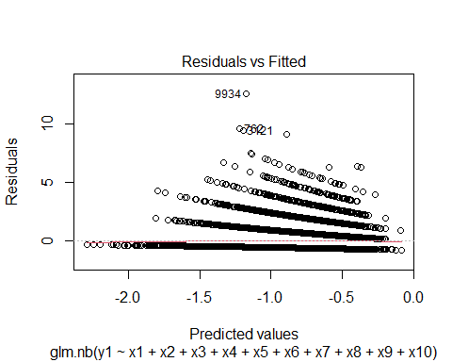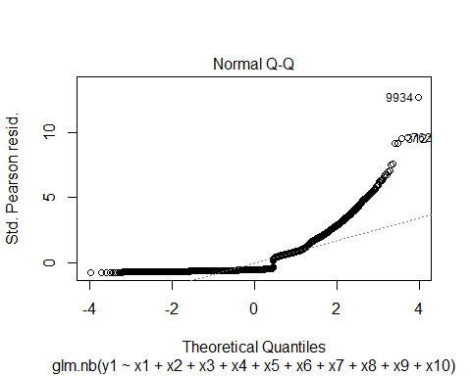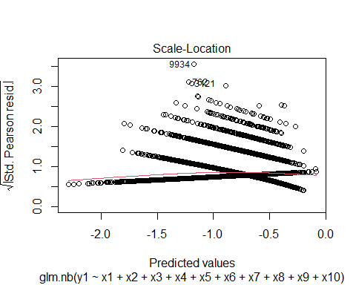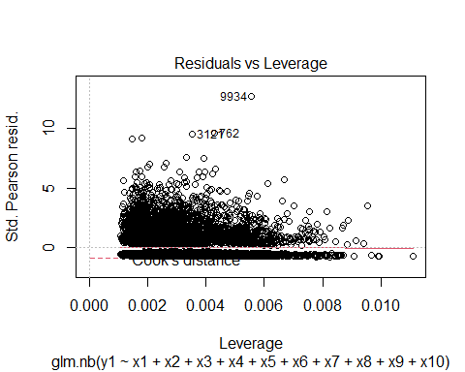

# 

# Severity Model

# ——————————————————————————————-

# 1- Log Normal Distributions

glm.lognorm<- glm(formula = log(y2) ~ x1 + x2 + x3 + x4 + x5+ x6 + x7 + x8 + x9 + x10,family = gaussian(link = "identity"), data = sevrity_df)

# 1.1- Summary Log Normal Distributions

##   
## Call:  
## glm(formula = log(y2) ~ x1 + x2 + x3 + x4 + x5 + x6 + x7 + x8 +   
## x9 + x10, family = gaussian(link = "identity"), data = sevrity_df)  
##   
## Deviance Residuals:   
## Min 1Q Median 3Q Max   
## -4.6452 -1.1952 0.0818 0.9404 4.5701   
##   
## Coefficients: (2 not defined because of singularities)

|  |  |  |  |  |
| --- | --- | --- | --- | --- |
| ## | Estimate | Std. Error | t value | Pr(>|t|) |
| (Intercept) | 7.910065 | 0.106079 | 74.568 | < 2e-16 *** |
| x1Female | 0.088053 | 0.054046 | 1.629 | 0.103334 |
| x225-30 | 0.172698 | 0.072388 | 2.386 | 0.017085 * |
| x2>60 | 0.062285 | 0.068656 | 0.907 | 0.364346 |
| x218-24 | -0.007216 | 0.108415 | -0.067 | 0.946938 |
| x3Engineer/Programmer | 0.007235 | 0.057921 | 0.125 | 0.900602 |
| x3Medical Profession | -0.131025 | 0.080743 | -1.623 | 0.104714 |
| x3Business man/woman | 0.125679 | 0.099967 | 1.257 | 0.208743 |
| x3Free Lancer | 0.022680 | 0.071825 | 0.316 | 0.752192 |
| x3Student | 0.050680 | 0.123217 | 0.411 | 0.680867 |
| x3Others | 0.213290 | 0.058220 | 3.664 | 0.000252 *** |
| x4Khartoum Bahari | -0.112277 | 0.048345 | -2.322 | 0.020253 * |
| x4Oumdrman | 0.020319 | 0.046736 | 0.435 | 0.663763 |
| x56-10 | -0.084219 | 0.055353 | -1.521 | 0.128207 |
| x511-20 | -0.059934 | 0.061610 | 0.973 | 0.330703 |
| x5>20 | 0.015047 | 0.061901 | 0.243 | 0.807948 |
| x6Japan | 0.752328 | 0.170575 | 4.411 | 1.05e-05 *** |
| x6Sudan | -0.195592 | 0.094982 | -2.059 | 0.039525 * |
| x6Germany | 0.645066 | 0.195744 | 3.295 | 0.000990 *** |
| x6Czech | 0.462701 | 0.151753 | 3.049 | 0.002309 ** |
| x6Others | 0.305336 | 0.224980 | 1.357 | 0.174792 |
| x7Kia | 0.224014 | 0.111944 | 2.001 | 0.045437 * |
| x7Toyota | -0.349977 | 0.211952 | -1.651 | 0.098763 . |
| x7Mitsubishi | -0.317129 | 0.262349 | -1.209 | 0.226799 |
| x7Giad | NA | NA | NA | NA |
| x7Mercedes | 0.119521 | 0.270269 | 0.442 | 0.658343 |
| x7Skoda | NA | NA | NA | NA |
| x7Others | -0.179336 | 0.154773 | -1.159 | 0.246636 |
| x8Click | 0.092765 | 0.097933 | 0.947 | 0.343568 |
| x8Tucson | 0.318499 | 0.155343 | 2.050 | 0.040391 * |
| x8Santa Fe | 0.281598 | 0.181621 | 1.550 | 0.121097 |
| x8Visto | -0.290640 | 0.204721 | -1.420 | 0.155764 |
| x8Corolla | -0.036232 | 0.146265 | -0.248 | 0.804365 |
| x8Hilux | -0.096248 | 0.196806 | -0.489 | 0.624830 |
| x8Prado/Land Cruiser | 0.228549 | 0.207717 | 1.100 | 0.271264 |
| x8Lancer | -0.126127 | 0.248185 | -0.508 | 0.611338 |
| x8BYD | -0.025164 | 0.177674 | -0.142 | 0.887379 |
| x8Others | 0.066404 | 0.083075 | 0.799 | 0.424143 |
| x90-5 | 0.449709 | 0.051897 | 8.665 | < 2e-16 *** |
| x911-20 | -0.188908 | 0.052289 | -3.613 | 0.000306 *** |
| x9>20 | -0.574657 | 0.141593 | -4.059 | 5.02e-05 *** |
| x10Medium | 0.170318 | 0.080163 | 2.125 | 0.033669 * |
| x10Large | -0.126520 | 0.139028 | -0.910 | 0.362851 |

## ---  
## Signif. codes: 0 '***' 0.001 '**' 0.01 '*' 0.05 '.' 0.1 ' ' 1  
##   
## (Dispersion parameter for gaussian family taken to be 1.781142)  
##   
## Null deviance: 8961.6 on 4728 degrees of freedom  
## Residual deviance: 8350.0 on 4688 degrees of freedom  
## AIC: 16193  
##   
## Number of Fisher Scoring iterations: 2

# 1.2- ANOVA Log Normal Distributions

## Analysis of Deviance Table  
##   
## Model: gaussian, link: identity  
##   
## Response: log(y2)  
##   
## Terms added sequentially (first to last)  
##   
##

|  |  |  |  |  |  |
| --- | --- | --- | --- | --- | --- |
| ## | Df | Deviance | Resid. Df | Resid. Dev | Pr(>Chi) |
| NULL |  |  | 4728 | 8961.6 |  |
| x1 | 1 | 5.326 | 4727 | 8956.2 | 0.0837724 . |
| x2 | 3 | 29.829 | 4724 | 8926.4 | 0.0007966 *** |
| x3 | 6 | 39.464 | 4718 | 8886.9 | 0.0011343 ** |
| x4 | 2 | 14.633 | 4716 | 8872.3 | 0.0164429 * |
| x5 | 3 | 8.748 | 4713 | 8863.6 | 0.1784141 |
| x6 | 5 | 100.678 | 4708 | 8762.9 | 6.337e-11 *** |
| x7 | 5 | 25.684 | 4703 | 8737.2 | 0.0131520 * |
| x8 | 10 | 115.994 | 4693 | 8621.2 | 3.839e-10 *** |
| x9 | 3 | 255.208 | 4690 | 8366.0 | < 2.2e-16 *** |
| x10 | 2 | 16.010 | 4688 | 8350.0 | 0.0111726 * |

## ---  
## Signif. codes: 0 '***' 0.001 '**' 0.01 '*' 0.05 '.' 0.1 ' ' 1

# 1.3- Ploting Log Normal Distributions

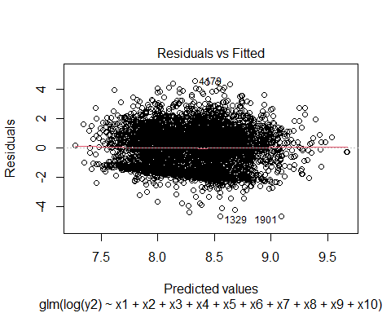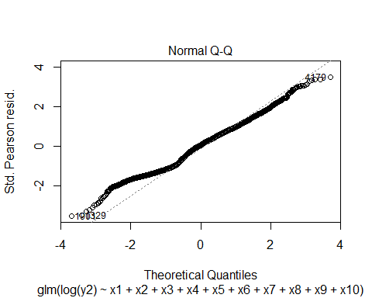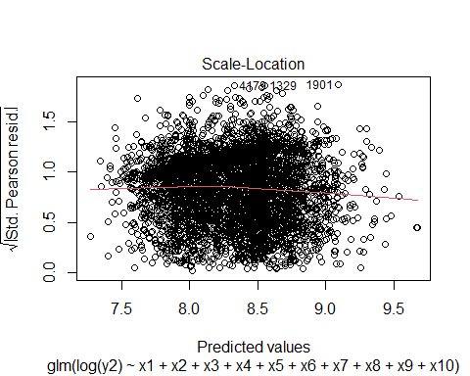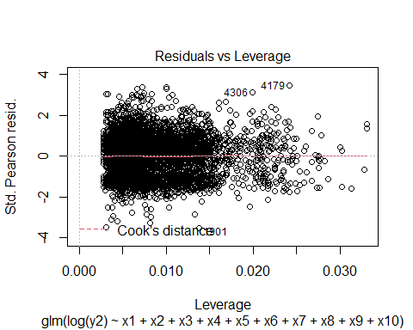

# 2- Gamma Distribution

glm.gamma <- glm(formula = y2 ~ x1 + x2 + x3 + x4 + x5+ x6 + x7 + x8 + x9 + x10, family = Gamma(link = "log"), data = sevrity_df)

# 2.1- Summary Gama

##   
## Call:  
## glm(formula = y2 ~ x1 + x2 + x3 + x4 + x5 + x6 + x7 + x8 + x9 +   
## x10, family = Gamma(link = "log"), data = sevrity_df)  
##   
## Deviance Residuals:   
## Min 1Q Median 3Q Max   
## -3.0114 -1.5444 -0.6948 0.0711 7.0088   
##   
## Coefficients: (2 not defined because of singularities)

|  |  |  |  |  |  |  |  |
| --- | --- | --- | --- | --- | --- | --- | --- |
| ## | | Estimate | | Std. Error | t value | | Pr(>|t|) |
| (Intercept) | | 8.738e+00 | | 1.578e-01 | 55.374 | | < 2e-16 *** |
| x1Female | | 7.820e-03 | | 8.039e-02 | 0.097 | | 0.922517 |
| x225-30 | | 1.076e-01 | | 1.077e-01 | 0.999 | | 0.317677 |
| x2>60 | | -1.443e-01 | | 1.021e-01 | -1.413 | | 0.157647 |
| x218-24 | | -1.754e-02 | | 1.613e-01 | -0.109 | | 0.913372 |
| x3Engineer/Programmer | | -9.940e-02 | | 8.616e-02 | -1.154 | | 0.248702 |
| x3Medical Profession | | -8.080e-02 | | 1.201e-01 | -0.673 | | 0.501126 |
| x3Business man/woman | | 9.480e-02 | | 1.487e-01 | 0.637 | | 0.523831 |
| x3Free Lancer | | -7.836e-03 | | 1.068e-01 | -0.073 | | 0.941539 |
| x3Student | | -1.120e-01 | | 1.833e-01 | -0.611 | | 0.541266 |
| x3Others | | 1.082e-01 | | 8.660e-02 | 1.249 | | 0.211722 |
| x4Khartoum Bahari | | -1.300e-01 | | 7.191e-02 | -1.808 | | 0.070694 . |
| x4Oumdrman | | -4.626e-04 | | 6.952e-02 | -0.007 | | 0.994691 |
| x56-10 | | -6.086e-02 | | 8.234e-02 | -0.739 | | 0.459846 |
| x511-20 | | -1.177e-01 | | 9.165e-02 | -1.284 | | 0.199123 |
| x5>20 | | 8.104e-02 | | 9.208e-02 | 0.880 | | 0.378857 |
| x6Japan | | 9.706e-01 | | 2.537e-01 | 3.825 | | 0.000132 *** |
| x6Sudan | | -3.562e-01 | | 1.413e-01 | -2.521 | | 0.011741 * |
| x6Germany | | 8.502e-01 | | 2.912e-01 | 2.920 | | 0.003517 ** |
| x6Czech | | 1.533e-01 | | 2.257e-01 | 0.679 | | 0.497163 |
| x6Others | | 4.886e-01 | | 3.347e-01 | 1.460 | | 0.144402 |
| x7Kia | | -4.703e-02 | | 1.665e-01 | -0.282 | | 0.777648 |
| x7Toyota | | -5.809e-01 | | 3.153e-01 | -1.843 | | 0.065461 . |
| x7Mitsubishi | | -6.693e-01 | | 3.902e-01 | -1.715 | | 0.086418 . |
| x7Giad | NA | | NA | | NA | NA | |
| x7Mercedes | -9.380e-02 | | 4.020e-01 | | -0.233 | 0.815527 | |
| x7Skoda | NA | | NA | | NA | NA | |
| x7Others | -3.620e-01 | | 2.302e-01 | | -1.572 | 0.115932 | |
| x8Click | 2.527e-01 | | 1.457e-01 | | 1.735 | 0.082886 . | |
| x8Tucson | 2.709e-01 | | 2.311e-01 | | 1.172 | 0.241177 | |
| x8Santa Fe | 4.033e-02 | | 2.702e-01 | | 0.149 | 0.881325 | |
| x8Visto | 1.446e-01 | | 3.045e-01 | | 0.475 | 0.634973 | |
| x8Corolla | -7.713e-02 | | 2.176e-01 | | -0.355 | 0.722979 | |
| x8Hilux | -2.340e-01 | | 2.928e-01 | | -0.799 | 0.424127 | |
| x8Prado/Land Cruiser | 1.336e-01 | | 3.090e-01 | | 0.432 | 0.665566 | |
| x8Lancer | -9.446e-02 | | 3.692e-01 | | -0.256 | 0.798059 | |
| x8BYD | -9.859e-05 | | 2.643e-01 | | 0.000 | 0.999702 | |
| x8Others | 1.995e-01 | | 1.236e-01 | | 1.614 | 0.106591 | |
| x90-5 | 4.569e-01 | | 7.720e-02 | | 5.918 | 3.49e-09 *** | |
| x911-20 | -2.663e-01 | | 7.778e-02 | | -3.423 | 0.000624 *** | |
| x9>20 | -6.421e-01 | | 2.106e-01 | | -3.048 | 0.002313 ** | |
| x10Medium | 2.482e-01 | | 1.192e-01 | | 2.081 | 0.037470 * | |
| x10Large | 3.363e-01 | | 2.068e-01 | | 1.626 | 0.103958 | |

## ---  
## Signif. codes: 0 '***' 0.001 '**' 0.01 '*' 0.05 '.' 0.1 ' ' 1  
##   
## (Dispersion parameter for Gamma family taken to be 3.94114)  
##   
## Null deviance: 9071.2 on 4728 degrees of freedom  
## Residual deviance: 8318.0 on 4688 degrees of freedom  
## AIC: 96134  
##   
## Number of Fisher Scoring iterations: 9

# 2.2- ANOVA Gama

## Analysis of Deviance Table  
##   
## Model: Gamma, link: log  
##   
## Response: y2  
##   
## Terms added sequentially (first to last)  
##   
##

|  |  |  |  |  |  |
| --- | --- | --- | --- | --- | --- |
| ## | Df | Deviance | Resid. | Df Resid. Dev | Pr(>Chi) |
| NULL |  |  | 4728 | 9071.2 |  |
| x1 | 1 | 1.176 | 4727 | 9070.1 | 0.58494 |
| x2 | 3 | 7.601 | 4724 | 9062.5 | 0.58735 |
| x3 | 6 | 30.275 | 4718 | 9032.2 | 0.26235 |
| x4 | 2 | 20.189 | 4716 | 9012.0 | 0.07721 . |
| x5 | 3 | 27.732 | 4713 | 8984.3 | 0.07074 . |
| x6 | 5 | 124.165 | 4708 | 8860.1 | 7.445e-06 *** |
| x7 | 5 | 47.048 | 4703 | 8813.1 | 0.03565 * |
| x8 | 10 | 180.171 | 4693 | 8632.9 | 1.615e-06 *** |
| x9 | 3 | 295.877 | 4690 | 8337.0 | 3.493e-16 *** |
| x10 | 2 | 18.989 | 4688 | 8318.0 | 0.08990 . |

## ---  
## Signif. codes: 0 '***' 0.001 '**' 0.01 '*' 0.05 '.' 0.1 ' ' 1

# 2.3- Ploting Gamma

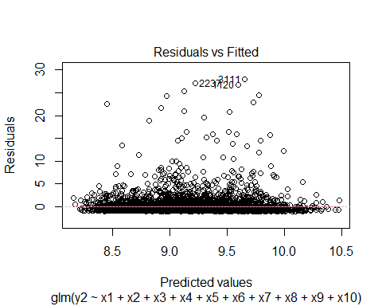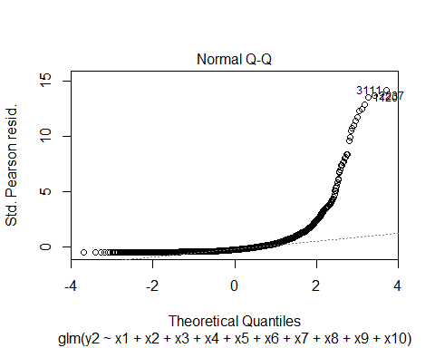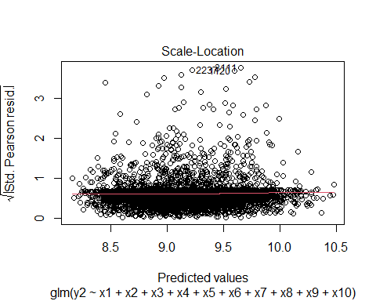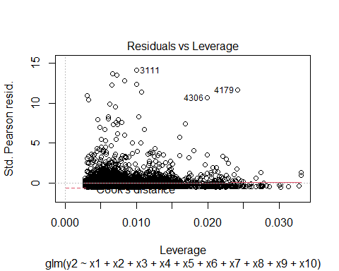

# Combine results of the Frequency Results Distributions Poisson & Negative binomial

##   
## =========================================================  
## Dependent variable:   
## -------------------------------  
## Frequency Distribution Results   
## Poisson negative   
## binomial   
## (1) (2)   
## ---------------------------------------------------------  
## x1Female 0.079** 0.081**   
## (0.034) (0.039)   
##   
## x225-30 -0.152*** -0.150***   
## (0.044) (0.050)   
##   
## x2> 60 0.168*** 0.171***   
## (0.043) (0.050)   
##   
## x218-24 -0.428*** -0.421***   
## (0.071) (0.078)   
##   
## x3Engineer and Programmer 0.040 0.038   
## (0.037) (0.043)   
##   
## x3Medical Profession -0.168*** -0.169***   
## (0.053) (0.060)   
##   
## x3Business man/woman -0.136** -0.137*   
## (0.063) (0.071)   
##   
## x3Free Lancer -0.246*** -0.248***   
## (0.046) (0.051)   
##   
## x3Student 0.045 0.030   
## (0.076) (0.086)   
##   
## x3Others -0.158*** -0.158***   
## (0.036) (0.042)   
##   
## x4Khartoum Bahari -0.084*** -0.085**   
## (0.030) (0.035)   
##   
## x4Oumdrman -0.131*** -0.131***   
## (0.030) (0.034)   
##   
## x56-10 -0.014 -0.015   
## (0.035) (0.040)   
##   
## x511-20 -0.210*** -0.213***   
## (0.039) (0.045)   
##   
## x5> 20 0.021 0.018   
## (0.039) (0.045)   
##   
## x6Japan 0.007 -0.001   
## (0.112) (0.125)   
##   
## x6Sudan 0.073 0.073   
## (0.063) (0.072)   
##   
## x6Germany 0.146 0.153   
## (0.124) (0.139)   
##   
## x6Czech 0.244** 0.245**   
## (0.097) (0.113)   
##   
## x6Others -0.099 -0.089   
## (0.141) (0.157)   
##   
## x7Kia 0.150** 0.161**   
## (0.070) (0.081)   
##   
## x7Toyota -0.016 -0.002   
## (0.138) (0.155)   
##   
## x7Mitsubishi 0.002 0.023   
## (0.168) (0.187)   
##   
## x7Giad   
##   
##   
## x7Mercedes -0.114 -0.097   
## (0.169) (0.190)   
##   
## x7Skoda   
##   
##   
## x7Others -0.098 -0.092   
## (0.102) (0.115)   
##   
## x8Click -0.190*** -0.185***   
## (0.062) (0.070)   
##   
## x8Tucson 0.335*** 0.349***   
## (0.097) (0.109)   
##   
## x8Santa Fe 0.449*** 0.464***   
## (0.113) (0.128)   
##   
## x8Visto -0.421*** -0.433***   
## (0.135) (0.152)   
##   
## x8Corolla 0.083 0.079   
## (0.094) (0.107)   
##   
## x8Hilux 0.405*** 0.407***   
## (0.124) (0.139)   
##   
## x8Prado / Land Cruiser 0.396*** 0.399***   
## (0.129) (0.146)   
##   
## x8Lancer -0.092 -0.102   
## (0.156) (0.176)   
##   
## x8BYD -0.045 -0.041   
## (0.114) (0.132)   
##   
## x8Others -0.102* -0.103   
## (0.055) (0.063)   
##   
## x90-5 0.040 0.038   
## (0.032) (0.037)   
##   
## x911-20 -0.185*** -0.188***   
## (0.033) (0.037)   
##   
## x9> 20 -0.447*** -0.454***   
## (0.088) (0.097)   
##   
## x10Medium 0.017 0.014   
## (0.054) (0.062)   
##   
## x10Large -0.464*** -0.479***   
## (0.089) (0.099)   
##   
## Constant -0.516*** -0.512***   
## (0.070) (0.080)   
##   
## ---------------------------------------------------------  
## Observations 14,685 14,685   
## Log Likelihood -13,262.130 -13,028.380   
## theta 1.534*** (0.096)  
## Akaike Inf. Crit. 26,606.260 26,138.760   
## =========================================================  
## Note: *p<0.1; **p<0.05; ***p<0.01

# Combine results of the Severity Results Distributions

##   
## ===================================================================  
## Dependent variable:   
## -----------------------------------------  
## Severity Distribution Results y2   
## normal glm: Gamma   
## link = log   
## (1) (2)   
## -------------------------------------------------------------------  
## x1Female 0.088 0.008   
## (0.054) (0.080)   
##   
## x225-30 0.173** 0.108   
## (0.072) (0.108)   
##   
## x2> 60 0.062 -0.144   
## (0.069) (0.102)   
##   
## x218-24 -0.007 -0.018   
## (0.108) (0.161)   
##   
## x3Engineer and Programmer 0.007 -0.099   
## (0.058) (0.086)   
##   
## x3Medical Profession -0.131 -0.081   
## (0.081) (0.120)   
##   
## x3Business man/woman 0.126 0.095   
## (0.100) (0.149)   
##   
## x3Free Lancer 0.023 -0.008   
## (0.072) (0.107)   
##   
## x3Student 0.051 -0.112   
## (0.123) (0.183)   
##   
## x3Others 0.213*** 0.108   
## (0.058) (0.087)   
##   
## x4Khartoum Bahari -0.112** -0.130*   
## (0.048) (0.072)   
##   
## x4Oumdrman 0.020 -0.0005   
## (0.047) (0.070)   
##   
## x56-10 -0.084 -0.061   
## (0.055) (0.082)   
##   
## x511-20 -0.060 -0.118   
## (0.062) (0.092)   
##   
## x5> 20 0.015 0.081   
## (0.062) (0.092)   
##   
## x6Japan 0.752*** 0.971***   
## (0.171) (0.254)   
##   
## x6Sudan -0.196** -0.356**   
## (0.095) (0.141)   
##   
## x6Germany 0.645*** 0.850***   
## (0.196) (0.291)   
##   
## x6Czech 0.463*** 0.153   
## (0.152) (0.226)   
##   
## x6Others 0.305 0.489   
## (0.225) (0.335)   
##   
## x7Kia 0.224** -0.047   
## (0.112) (0.167)   
##   
## x7Toyota -0.350* -0.581*   
## (0.212) (0.315)   
##   
## x7Mitsubishi -0.317 -0.669*   
## (0.262) (0.390)   
##   
## x7Giad   
##   
##   
## x7Mercedes 0.120 -0.094   
## (0.270) (0.402)   
##   
## x7Skoda   
##   
##   
## x7Others -0.179 -0.362   
## (0.155) (0.230)   
##   
## x8Click 0.093 0.253*   
## (0.098) (0.146)   
##   
## x8Tucson 0.318** 0.271   
## (0.155) (0.231)   
##   
## x8Santa Fe 0.282 0.040   
## (0.182) (0.270)   
##   
## x8Visto -0.291 0.145   
## (0.205) (0.305)   
##   
## x8Corolla -0.036 -0.077   
## (0.146) (0.218)   
##   
## x8Hilux -0.096 -0.234   
## (0.197) (0.293)   
##   
## x8Prado / Land Cruiser 0.229 0.134   
## (0.208) (0.309)   
##   
## x8Lancer -0.126 -0.094   
## (0.248) (0.369)   
##   
## x8BYD -0.025 -0.0001   
## (0.178) (0.264)   
##   
## x8Others 0.066 0.199   
## (0.083) (0.124)   
##   
## x90-5 0.450*** 0.457***   
## (0.052) (0.077)   
##   
## x911-20 -0.189*** -0.266***   
## (0.052) (0.078)   
##   
## x9> 20 -0.575*** -0.642***   
## (0.142) (0.211)   
##   
## x10Medium 0.170** 0.248**   
## (0.080) (0.119)   
##   
## x10Large -0.127 0.336   
## (0.139) (0.207)   
##   
## Constant 7.910*** 8.738***   
## (0.106) (0.158)   
##   
## -------------------------------------------------------------------  
## Observations 4,729 4,729   
## Log Likelihood -8,055.490 -48,025.780  
## Akaike Inf. Crit. 16,192.980 96,133.550   
## ===================================================================  
## Note: *p<0.1; **p<0.05; ***p<0.01